**LAPTOP PRICE PREDICTOR**

**PRESENTED** **BY:**

KASHVI SHARMA(2201990499**)**

KHUSHI GUPTA(2210990512)

KESHAV WADHWA (2210990506**)**

**UNDER SUPERVISION OF**MR. JATIN ARORA

DEPARTMENT OF COMPUTER SCIENCE AND ENGINEERING

## INDEX

* Introduction
* Problem Statement
* Technologies/Methods Used
* Results
* Conclusion
* Questions
* References

## INTRODUCTION

* Our project uses machine learning to predict laptop prices accurately.
* We employ advanced algorithms such as linear regression , Decision tree , SVM etc.
* We analyze various factors like hardware specifications and market conditions.
* Users can make well-informed purchasing decisions with our predictions
* Our goal is to empower consumers to navigate the laptop market confidently.

## PROBLEM STATEMENT

1. Accurately predicting laptop prices is challenging due to diverse models, fluctuating consumer preferences, and technological advancements.
2. A robust predictive model leveraging machine learning is essential for precise laptop price forecasts based on features like processor type, RAM size, brand reputation, and market trends.
3. The Predictive model must adapt to changing market conditions and consumer behaviour to effectively guide pricing decisions.

## TECHNOLOGIES/METHODS USED

**Python**: The project was developed using Python, a versatile programming language known for its readability and extensive libraries.

**Libraries:**

**NumPy**: Utilized for efficient numerical operations and array manipulation.

**Matplotlib**: Employed for creating visualisations and graphs to analyse data.

**Seaborn**: Used to enhance the aesthetics of visualisations & statistical data exploration.

**Pandas**: Utilized for data manipulation and analysis, offering powerful data structures and functions.

**Scikit-learn (sklearn)**: Utilized for implementing machine learning algorithms, model evaluation, and preprocessing.

**Machine Learning Models:**

**Linear regression:** Linear regression finds the best-fit line to predict the relationship between independent and dependent variables by minimizing the sum of squared errors.

**Decision Tree**: Employed for both classification and regression tasks, partitioning data into subsets based on feature values.

**Random Forest**: Utilized as an ensemble learning method, constructing multiple decision trees to improve accuracy and robustness.

**KNN algorithm :** The k-nearest neighbors (KNN) algorithm is a non-parametric, supervised learning classifier, which uses proximity to make classifications or predictions about the grouping of an individual data point. It is one of the popular and simplest classification and regression classifiers used in machine learning today.

**Lasso Regression:**  Lasso regression is particularly useful for high-dimensional data and enhances model interpretability compared to other regularization techniques like ridge regression. It's also applicable in logistic regression for similar regularization benefits.

**Support Vector machine:** A support vector machine (SVM) is defined as a machine learning algorithm that uses supervised learning models to solve complex classification, regression outlier detection problems by performing optimal data transformations that determine boundaries between data points

5

**RESULT**

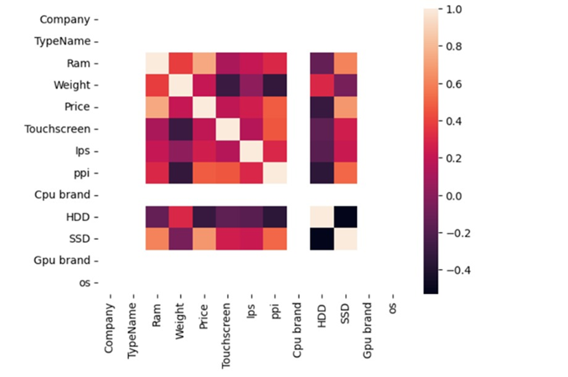

Fig 19.Overall, the correlation heatmap serves as a visual aid to understand the relationships between variables in your dataset and to guide further analysis

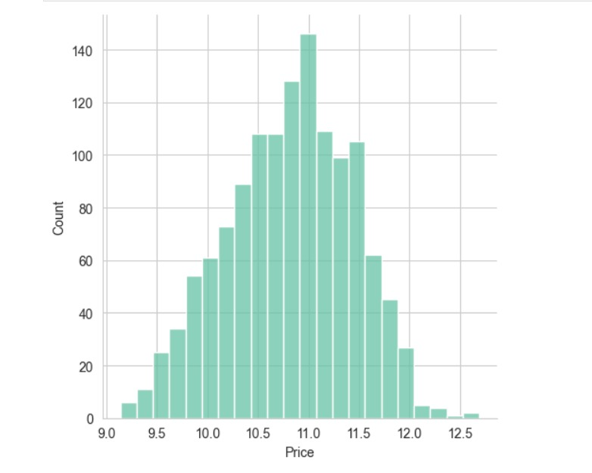

Fig. This visualization helps in understanding the distribution of the logarithm of prices in your dataset, which might be useful for certain statistical analyses or for visualizing data that has a wide range of values

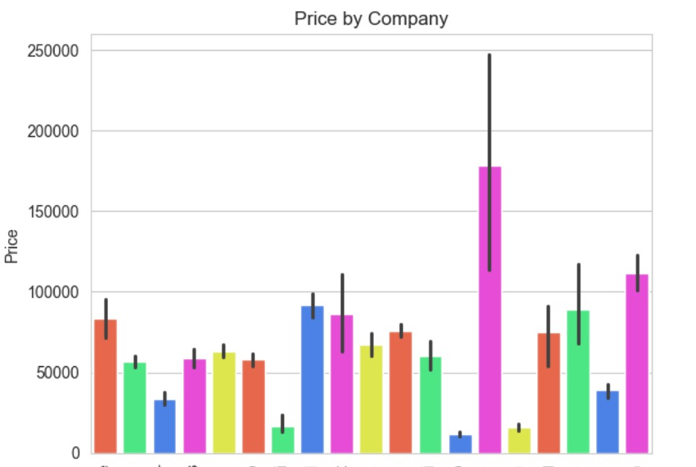

Fig .represents the distribution of prices within the dataset. The x-axis typically represents the range of prices, while the y-axis represents the frequency or density of occurrence of those prices.

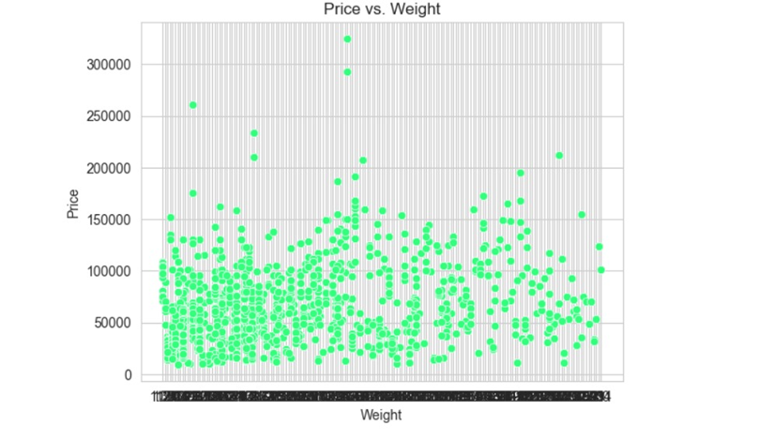

Fig Overall, the correlation heatmap serves as a visual aid to understand the relationships between variables in your dataset and to guide further analysis

## CONCLUSION

In conclusion, our project underscores the importance of employing artificial intelligence and machine learning in predicting laptop prices accurately. By utilizing techniques such as linear regression, support vector machines,

we've demonstrated how these methods can analyze diverse features to provide users with reliable pricing forecasts.

Our aim is to empower consumers to make informed decisions in the laptop market, ensuring they obtain optimal value for their investment.

**REFERENCES:-**

**5.1 Data Set:**

<https://www.kaggle.com/datasets/mohidabdulrehman/laptop-price-dataset>

**5.2 Study Material:**

<https://www.analyticsvidhya.com/blog/2021/11/laptop-price-prediction-practical-understanding-of-machine-learning-project-lifecycle/>

<https://www.researchgate.net/publication/377721653_Machine_Learning-Based_Price_Prediction_for_Laptops>

<https://youtu.be/BgpM2IiCH6k?si=neGsfObQVmONG0Ht>

